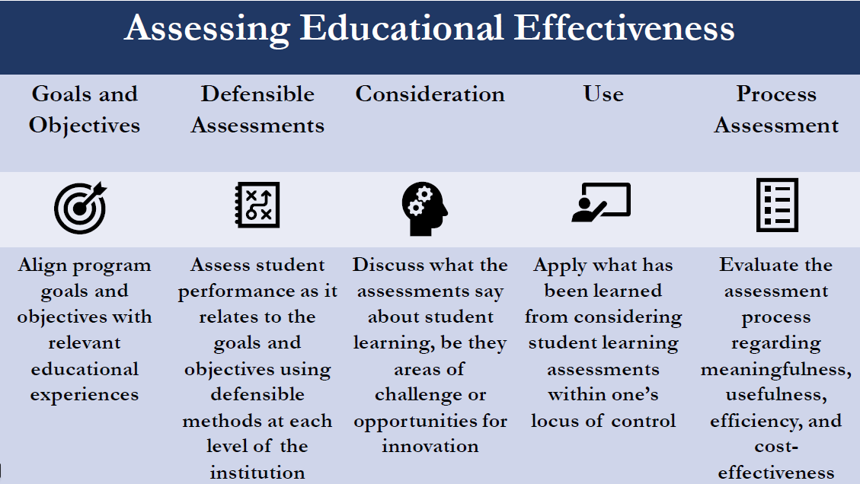

SOURCE: McKitrick, Sean A. Demonstrating Student Achievement. Presentation at the Middle States Conference on Higher Education Self-Study Institute, Philadelphia, PA, 7 Nov. 2018

